Chapter 12

Managing Inventory

**Background**

This chapter is arguably the most important in the book. Some suggest that inventory management is the “heart and soul” of operations management. The chapter contains quite a few formulas. While none of the techniques are particularly difficult, the primary challenge for students is applying the correct technique to the problem at hand. Identifying the proper modeling environment is the key. The qualitative aspects of the lecture can be enhanced by relating some of these inventory issues to students’ personal lives. Everyone stores inventory in their homes and workplaces, so they should be able to see the connection to some of these issues. For example, driving to the price club involves a setup cost, storing winter clothes takes up much needed space, a sale on Ramon noodles may entice students to stock up, etc.

**Class Discussion Ideas**

1. The University Bookstore is generally a good site to investigate the full range of independent demand inventory decisions. It’s especially interesting when there is a stockout! Instructors might see if they can get the Bookstore Manager to discuss some of these issues in class and answer the students’ questions.

2. Have students describe how they manage the groceries they buy, and analyze their inventory policies. Do any of them purchase in bulk at a price club? How do they purchase for an upcoming party that they will be hosting? Does any of their food ever spoil? Do they visit the grocery store on a periodic basis or when they run out of something? When they go, do they try to stock up on all regular items in the same trip?

**Active Classroom Learning Exercises**

1. Inventory simulation game: “He Shoots, He Scores.” See Other Supplementary Material below.

2. After the students have worked though the basic EOQ model and costs, have them split into small groups to try to identify other costs beyond the basic ordering and holding costs that might affect inventory decisions. Each group can share their findings with the class. This is a good opportunity to identify more advanced models and approaches.

**Company Videos**

1. *Managing Inventory at Frito-Lay (8:03)*

This video shows many scenes of the production process at the plant level and focuses on the inventory needs at the Frito-Lay plants. All four types of inventory described in the text are discussed in the video. Frito-Lay has five main types of raw materials: potatoes, corn, oil, salt and seasoning, and packaging. Overall inventory turnover is 150 times per year, and in most cases less than one week’s worth of raw materials are on hand. Potatoes, in particular, require many deliveries and only about 20 hours worth of inventory in the factories because potatoes break down quickly once delivered. About one shift’s worth of work-in-process inventory is kept in the plant at any time. In many cases, finished goods go straight from the line to the truck and onto store shelves later that day. Proper inventory management is crucial for low cost but smooth production flow of this high-volume operation.

Prior to showing the video, instructors might ask students to consider what items need to be ordered and stored to make a potato chip. Afterwards, discussion might focus on the potato situation in particular. What challenges does Frito-Lay face with this fast-decaying raw material? How can multiple deliveries per day be sustained year round? What kinds of supplier relationships are required? What happens if a supply truck breaks down? What if a production machine breaks down?

What measures should Frito-Lay institute to mitigate these risks?

2. *Inventory Control at Wheeled Coach (6:20)*

Wheeled coach manufactures *custom* ambulances, which presents extra challenges for proper inventory control. With a lack of standardization of final products, forecasting demand levels for specific parts proves difficult. The company manages approximately 7000 different parts. Inventory is delivered just-in-time to the assembly line, and little work-in-process inventory exists. Wheeled Coach performs cycle counting of its items to ensure that inventory records match on-hand inventory levels at all times. The video presents a nice example of ABC analysis in practice. The “A” items, such as truck chassis, aluminum, and plywood, receive more attention and are cycle counted more frequently.

Prior to showing the video, instructors might ask students to guesstimate how much work-in-process inventory that they would expect to see in a production line that produces ambulances. Afterwards, discussion could focus on the almost complete lack of inventory in Wheeled Coach’s assembly line. What specific processes would need to be put in place to ensure that the right parts are brought to the line at the right times? What kinds of supplier relationships might be required? What would the internal information system need to be able to do? What happens if a part is missing?

**Cinematic Ticklers**

1. *Seinfeld, Season 7, Episode 121: “The Rye” (Jerry Seinfeld, Julia Louis-Dreyfus, Michael Richards, and Jason Alexander) NBC, Jan. 4, 1996*

The Downside of Quantity Discounts

In this episode, Kramer goes wild at the price club and purchases huge packages of certain items, including “Beef-A-Reeno.” To try to get rid of some of it, he begins feeding it to the carriage horse that he is taking care of for the week. When giving a ride to the parents of George’s fiancé, the horse develops a gas problem and the humor ensues.

2. *The Simpsons, Season 4: “A Streetcar Named Marge,”20th Century Fox Video, 2004 (1992-1993)*

The Decisions of a Newsboy

In this episode, Marge has the lead role in a community play musical version of “A Streetcar Named Desire.” In an early scene, she approaches a newsboy (played by Apu) and tells him that she wants to kiss him. Apu sings a short song: “I am just a simple paper boy, no romance do I seek....Will this bewitching floozy seduce this humble newsy? Oh what’s a paperboy to dooooooooooooooo?”

**Presentation Slides**

INTRODUCTION (12-1 through 12-10)

Slides 8-10: The Global Company Profile description of the Amazon.com order filling process is a nice one that includes some good detail. Note, in particular, Step 3, which represents a “pick-to-light” system. The lights direct workers to the exact bins to pick the proper items, doubling the picking speed while simultaneously eliminating almost all human errors stemming from matching products to numbers or descriptions. Throughout the system, computers, bar codes, and conveyor belts help to route products automatically to the appropriate boxes, which end up at the customers’ doorstep within about three days.



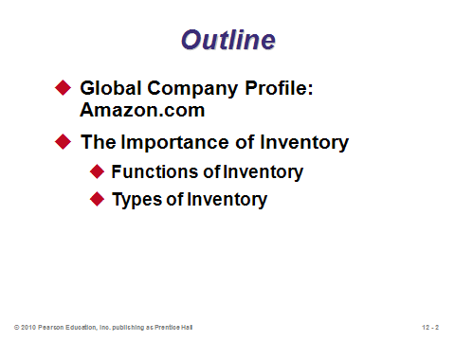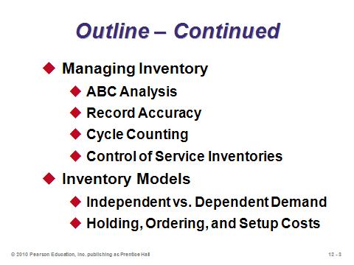

**12-1 12-2 12-3**

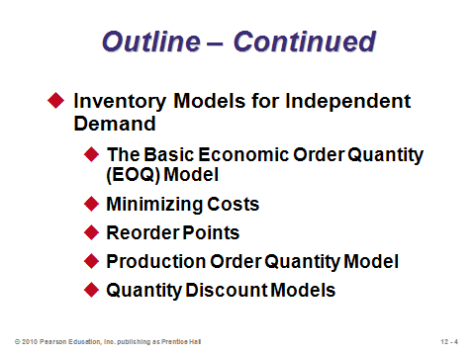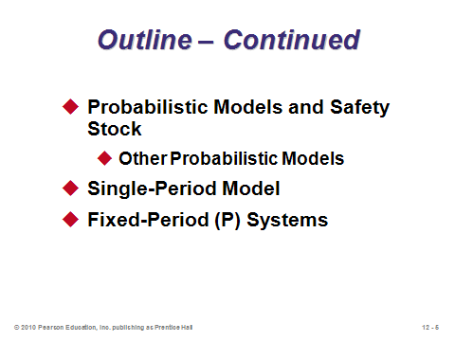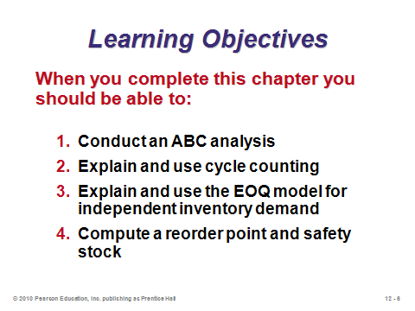

**12-4 12-5 12-6**

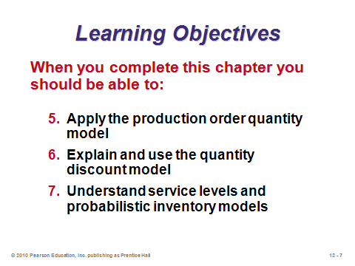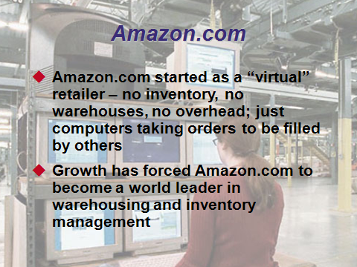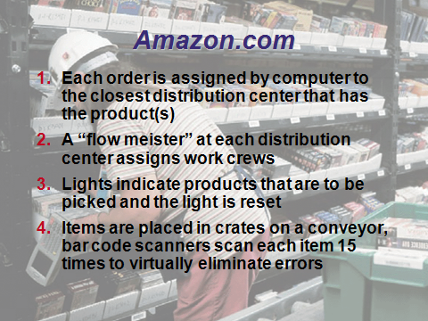

**12-7 12-8 12-9**

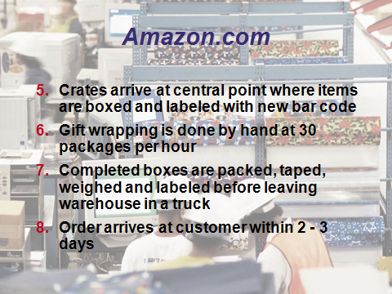

**12-10**

THE IMPORTANCE OF INVENTORY (12-11 through 12-15)

Slides 11-12: While the topic may not sound particularly “sexy” to students, inventory management is arguably the most important OM decision. OM researchers have written thousands of papers modeling every facet of inventory management imaginable. Companies tie up thousands or often millions of dollars in inventory, and the lost interest revenue alone on that money can represent a huge profit loss. On the other hand, companies that do not have the right goods at the right places at the right times may incur significant delays, backorder costs, or lost sales. Firms have had to go out of business due to poor inventory management.

Slide 13: These inventory functions can also be thought of as advantages of having inventory. Instructors can expand upon this list somewhat. For example, *anticipatory inventory* is built up during low- to medium-demand periods to get ready for an upcoming high-demand period (such as Christmas). This practice (*level* production policy—see Chapter 13) potentially avoids hiring and laying off workers, working extra overtime, etc. The *decoupling* (Function 1) allows operations to work at their own pace and permits constant production quantities. This use of *buffer stock* can occur between stations within a facility or between different companies in the supply chain. Finally, in addition to taking advantage of quantity discounts, firms may order or produce in large lots to exploit economies of scale in supply (spread a large setup cost over multiple items). This is also known as *cycle inventory*. While on Slide 13, instructors might take this opportunity to mention some of the disadvantages of having too much inventory. In addition to generating holding costs (described in detail later): (1) inventory can be difficult to control, store, and maintain, (2) handling inventory is a non-value added activity, (3) inventory reduces cash availability, which may be particularly troublesome for small firms, (4) having too much inventory runs the risk of product obsolescence or delays responsiveness to the market with new products, and (5) (as the Japanese remind us) having too much inventory may act as a bandage to help get around a problem, but in the long run this bandage may cover up the “wound” so that the firm cannot even identify the underlying problem (i.e., having no extra inventory exposes root problems in the system, which can then be corrected—creating a long-term competitive advantage).

Slide 14: This slide describes the four types of inventory. Raw material, WIP, and finished goods inventory represent what the firm will eventually sell to customers, while MRO inventory keeps the business running smoothly.

Slide 15: This is Figure 12.1 from the text, with the caption: “Most of the time that work is in-process (95% of the cycle time) is not productive time.”

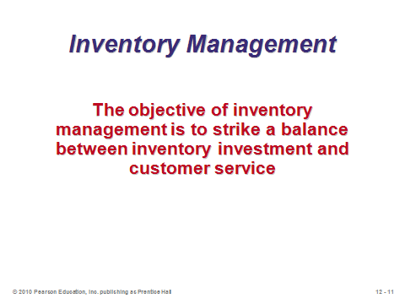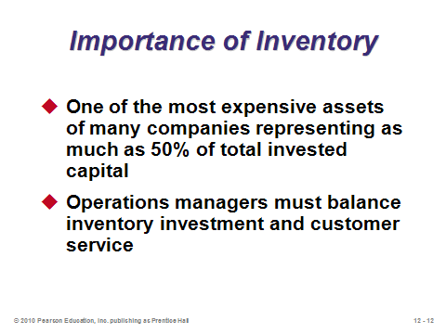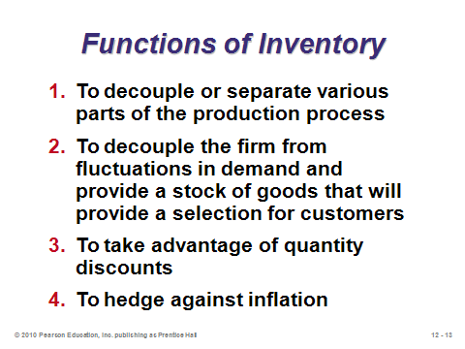

**12-11 12-12 12-13**

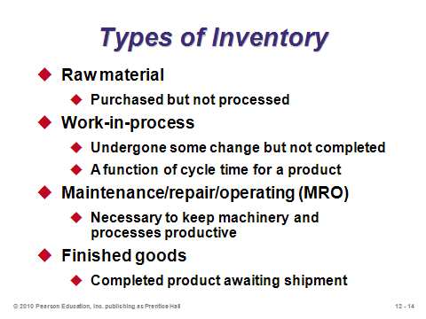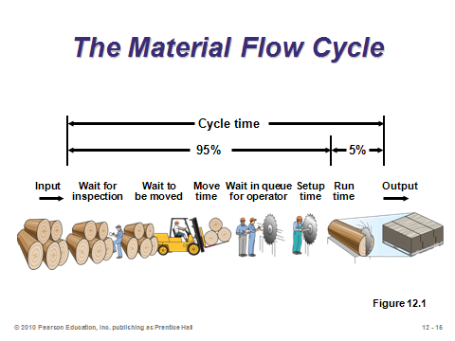

**12-14 12-15**

MANAGING INVENTORY (12-16 through 12-26)

Slides 17-22: These slides describe ABC analysis, which is often the first step in setting up an inventory control system. Based on the *Pareto principle*, the idea is to identify and then focus resources on the few critical parts, not the many trivial ones (such as paper clips). The cutoffs are not exact, but in general, Class A items represent about 15% of total inventory items and 70%-80% of total dollar usage. Class B items represent about 30% of total inventory items and 15%-25% of total dollar usage. Class C items represent about 55% of total inventory items but only 5% of total dollar usage. Slides 18 and 19 illustrate Example 1 from the text. Items are ranked in decreasing order of annual dollar volume (annual volume times unit cost), and the A-B-C cutoffs are made from there. Slide 20 (Figure 12.2) shows the typical graphical representation of ABC analysis. Slide 21 identifies other possible ways to rank items—the point being to help firms identify the items that need the most attention to address their particular issues. Slide 22 identifies some of the managerial actions to employ once the A (and to a lesser extent B) items have been identified.

Slide 23: Good inventory decisions rely on good data, so accurate record keeping of inventory is crucial. This process is challenging because inventory disappears for a variety of reasons: shoplifting, employee theft, breakage, spoilage, sales clerks/systems not correctly identifying sold items, etc.

Slides 24-25: Cycle counting is employed to more continuously count inventory and audit records than, say, an annual full physical count and reconciliation would entail. Slide 25 (Example 2) illustrates how such a system might be set up, based on ABC analysis. In this example, the A items are counted each month but through a rolling process, so some A items are counted every day to spread out the workload.

Slide 26: Service industries usually have inventory on hand, and in fact, a shortage of inventory in those environments (e.g., no shampoo at the salon or no coffee at the coffee shop) could even more readily result in lost sales. This slide identifies some techniques that can be employed to reduce the levels of shrinkage and pilferage.

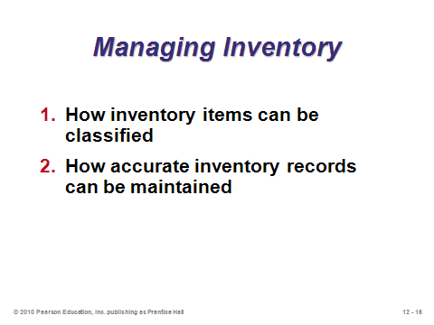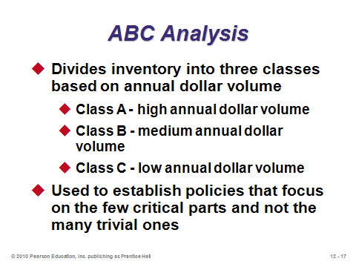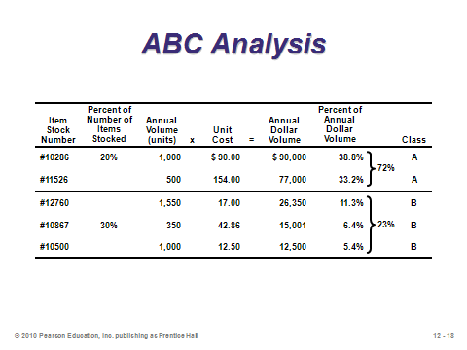

**12-16 12-17 12-18**

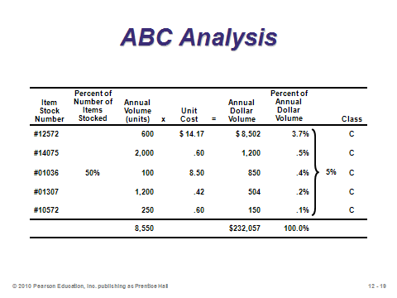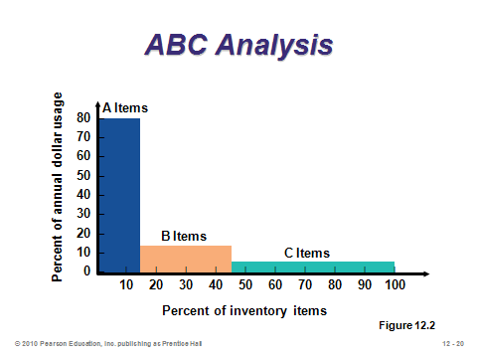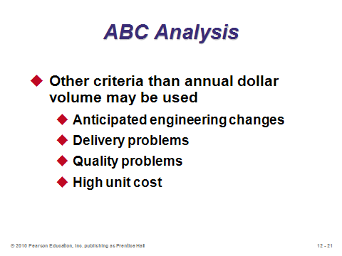

**12-19 12-20 12-21**

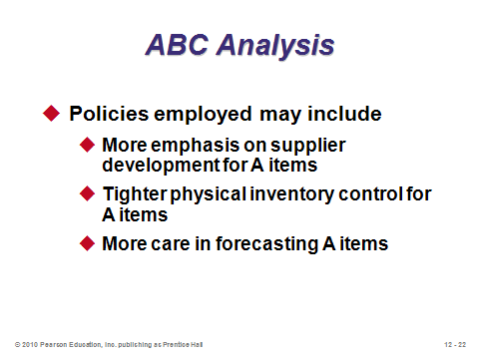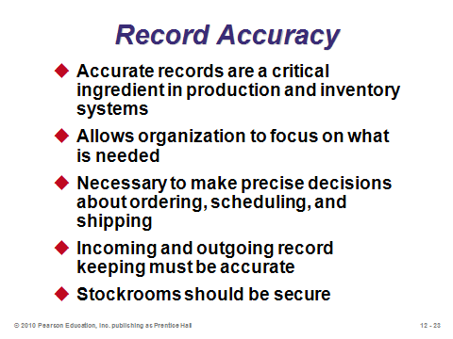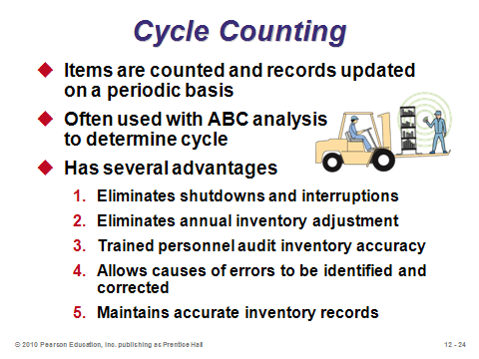

**12-22 12-23 12-24**

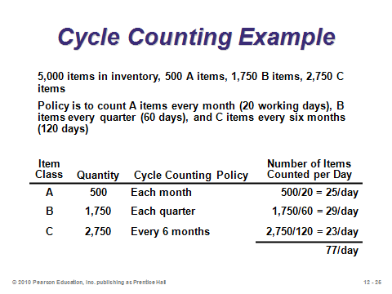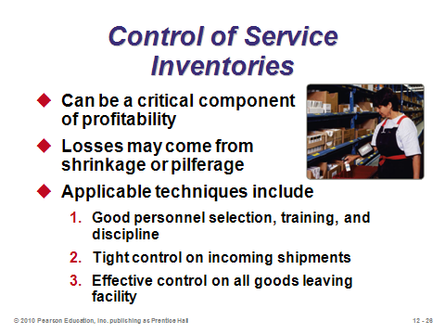

**12-25 12-26**

INVENTORY MODELS (12-27 through 12-30)

Slide 27: Demand characteristics determine which inventory models are appropriate. The models in Chapter 12 are applied to independent demand situations, while dependent demand is covered in Chapter 14. Two other demand distinctions include deterministic vs. stochastic and static (constant mean) vs. variable.

Slide 28: The primary tradeoff in lot sizing decisions of basic inventory models involves balancing ordering/setup costs and holding (carrying) costs. Larger lot sizes imply lower ordering/setup costs but higher holding costs, and vice versa.

Slides 29-30: Slide 29 (Table 12.1) illustrates some of the possible components that may comprise the overall holding cost. Interest on tied-up money is an important part of holding cost that students sometimes have trouble grasping. Even though inventory is listed as an asset in the accounting books, if, say, a $100 item is purchased and left on the store shelf for one year, the firm has lost the opportunity cost on that money. The rate used is often the weighted average cost of capital for the firm, but even the bank savings account interest rate could apply. For example, if the firm earns 5% on its deposit accounts with the bank, then it would have had $105 at the end of one year if it had left the money in the bank instead of purchasing the inventory item. Thus, the annual holding cost of that $100 item should be at least $5. Another item that could be mentioned as part of Slide 29 is worker’s compensation costs because the most common worker’s compensation claims stem from back injuries due to moving inventory.

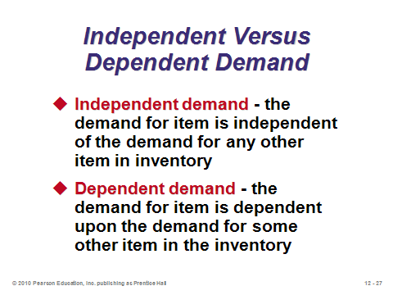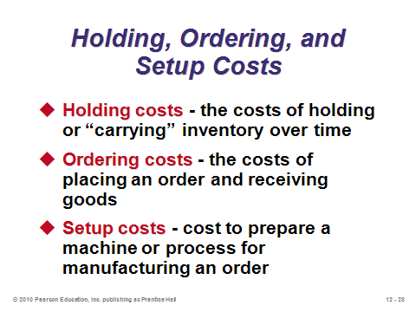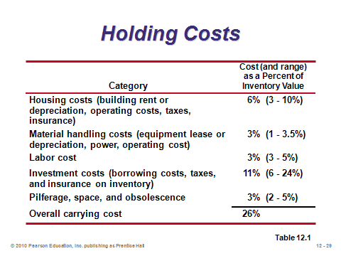

**12-27 12-28 12-29**

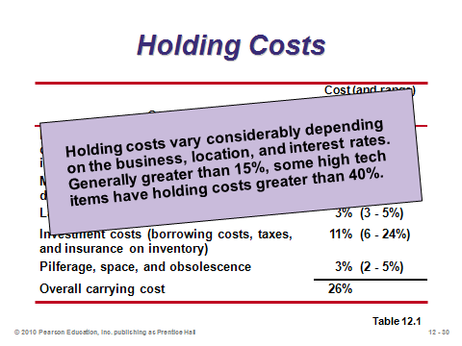

**12-30**

INVENTORY MODELS FOR INDEPENDENT DEMAND (12-31 through 12-61)

The Basic Economic Order Quantity (EOQ) Model (12-31 through 12-33)

Slide 32: It is important to cover the assumptions of the EOQ model. When any of these are relaxed, a more complicated model might apply better. There are actually a few other assumptions that can be mentioned as well: (1) the time horizon is infinite, (2) demand is not only constant period after period, but it is uniform (technically this implies that it is continuous and smooth, with no seasonality, large orders, or lumpiness—hence the straight declining lines in Slide 33), (3) there are no constraints on the order size, (4) decisions for one item are made independently of decisions for other items, and (5) there is no inflation. While these assumptions may seem restrictive and unrealistic, the EOQ is known to be a robust model and can at least provide a good base case or starting point decision.

Slide 33: Instructors should spend some time on this important graph (Figure 12.3). The EOQ assumption of instantaneous and complete receipt of inventory causes the line to shoot straight up when an order is placed. The assumption of constant (and uniform) demand causes the line to decline smoothly and continuously over time until the inventory level reaches zero, at which point another order must be placed. Since the time horizon is infinite and nothing about cost or demand conditions changes, this pattern repeats itself indefinitely. The graph also illustrates why we assume that average inventory on hand equals *Q* / 2.

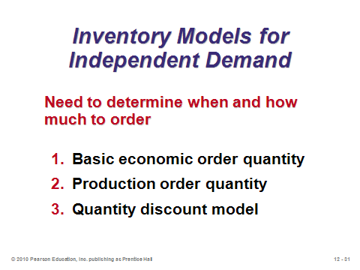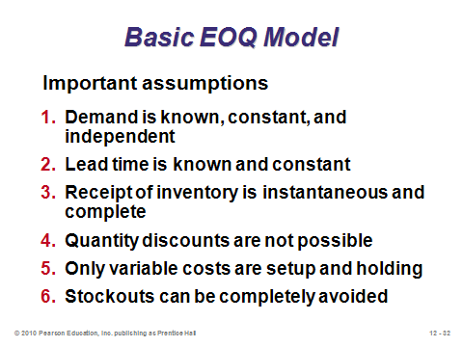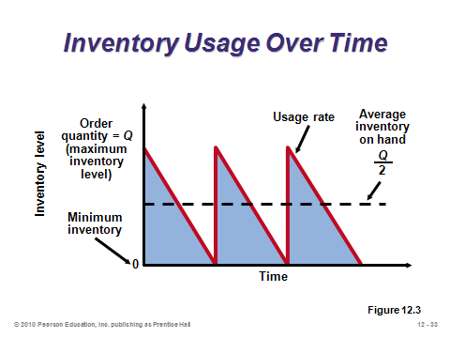

**12-31 12-32 12-33**

Minimizing Costs (12-34 through 12-44)

Slide 34: As the authors state, this graph (Figure 12.4(c)) is the heart of inventory modeling. It represents the essential tradeoff between ordering/setup cost and holding cost. With very small order sizes, ordering/setup cost is much higher than holding cost, and total cost would decrease by ordering more units each time. This continues, in fact, until ordering/setup cost exactly equals holding cost. At that point, the total cost curve reaches its minimum. (This can be shown analytically as well as graphically.)

Slides 35-37: These slides develop the EOQ formula. Keeping the notation at the top of each slide, we see the annual setup cost formula in Slide 35 and the annual holding cost formula in Slide 36. Slide 37 derives the optimal order quantity formula, knowing that annual setup and holding cost should be set equal to each other. For the more mathematically inclined students, the formula can also be derived by showing that the total cost formula is convex in *Q*, and the EOQ is the result of setting the first derivative equal to zero and solving for *Q* (see Footnote 3 in the text).

Slides 38-41: These slides present the continuing Examples 3 through 5 in the text. Slide 38 provides the order quantity. Slide 39 provides the expected number of orders per year for the same example (note that this value can be a fraction, implying that some years will be the rounded down integer while other years will be the rounded up integer). Slide 40 provides the expected time between orders (in days) for the same example. Slide 41 computes the total cost. Instructors may want to share that there is a shortcut formula for total cost of the EOQ model, which is based on the parameters only and not *Q*. If the EOQ is ordered, the total annual holding and setup cost will be. This can be derived by plugging *Q*\* into the general total setup and holding cost formula as a function of *Q*.

Slides 42-44: Slide 42 notes that due to the flat shape of the total cost function (see Slide 34), the EOQ model is robust, i.e., it often provides satisfactory answers even with substantial variation in the parameters. Slides 43-44 illustrate Example 6 from the text, which looks at the previous example under the condition that demand was underestimated by a full 50%. The important issue is not that costs will increase (they obviously will be higher along with higher demand no matter which model is used), but that the total cost using the wrong EOQ is less than 2% higher in this example than the total cost using the right EOQ (if demand had been known correctly).

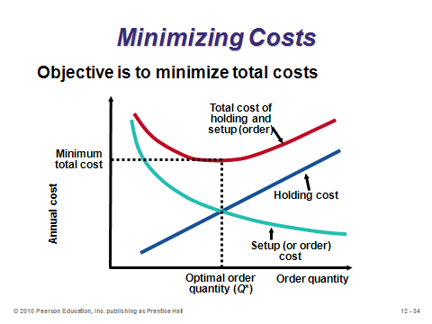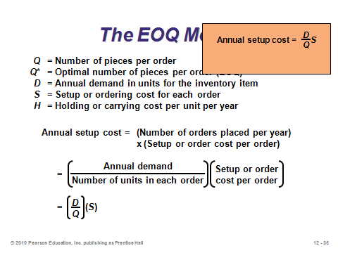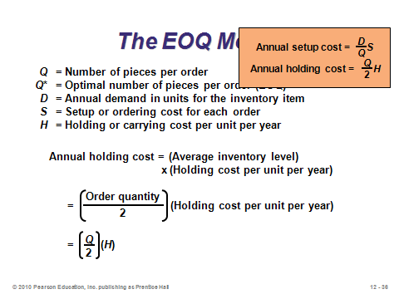

**12-34 12-35 12-36**

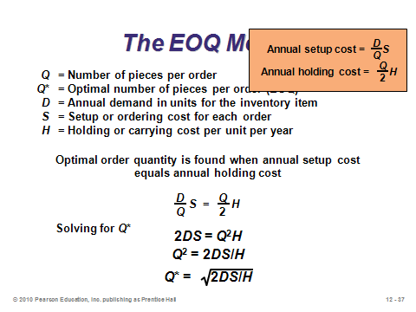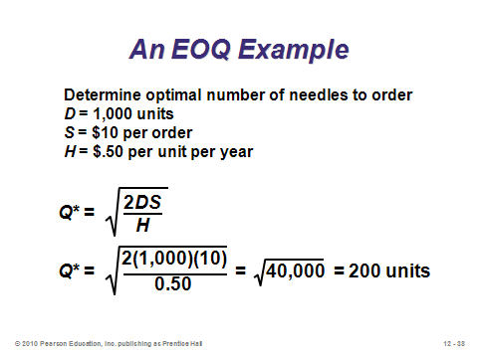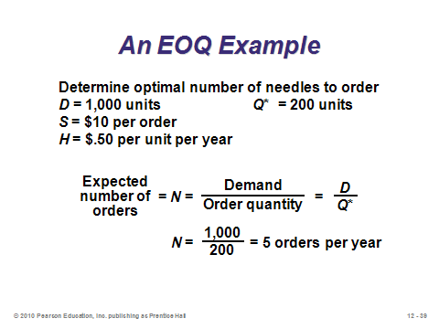

**12-37 12-38 12-39**

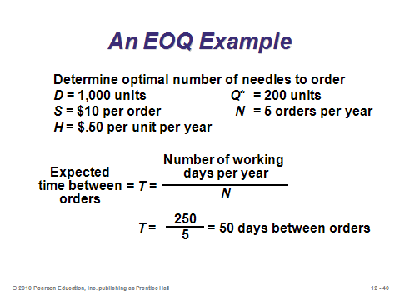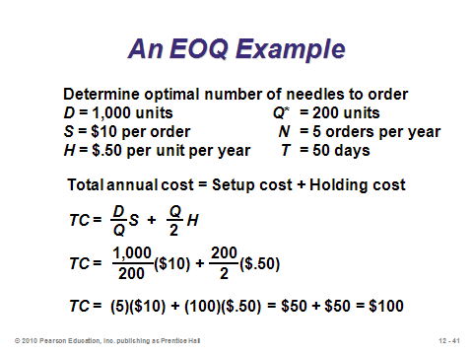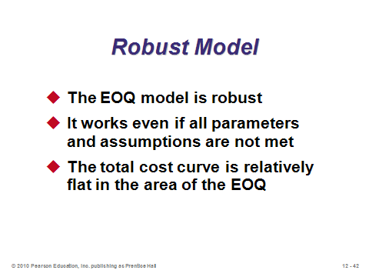

**12-40 12-41 12-42**

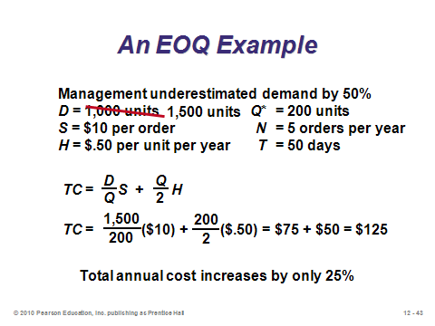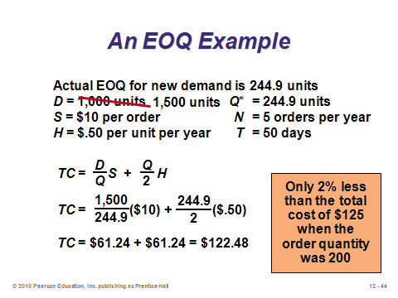

**12-43 12-44**

Reorder Points (12-45 through 12-47)

Slides 45-47: The basic EOQ model assumes that orders arrive instantaneously and completely. But when the (complete) orders take time to arrive, the timing of the order must account for this lead time. In other words, the firm must place the order before completely running out of inventory so that the new units have time to arrive before they are needed. Slide 45 provides the reorder point formula. Slide 46 (Figure 12.5) illustrates when (in units) the order should be placed. Slide 47 provides a reorder point calculation (Example 7).

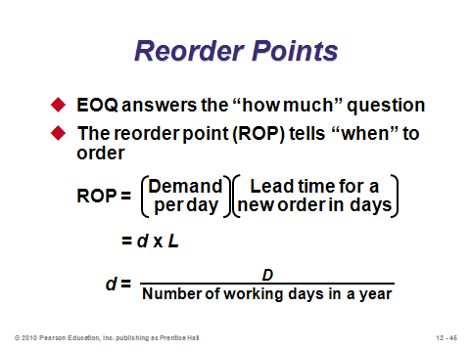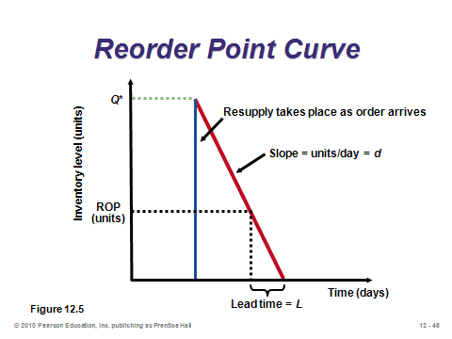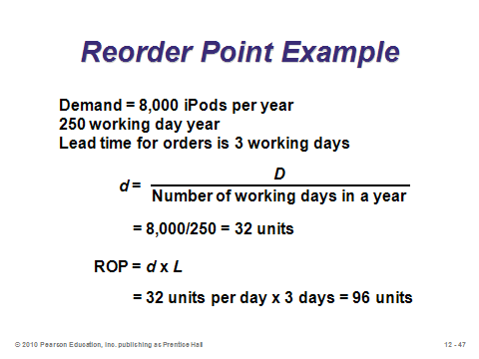

**12-45 12-46 12-47**

Production Order Quantity Model (12-48 through 12-54)

Slides 48-49: An important assumption of the basic EOQ model is that orders arrive instantaneously *and completely* (i.e., the production rate is infinite). While this assumption may be true for purchased parts, *produced* parts may take time to make. In particular, when units are produced and sold simultaneously, the EOQ graph changes to the one shown in Slide 49 (Figure 12.6). This necessitates a different model, the *Production Order Quantity (POQ) Model*.

Slides 50-52: These slides derive the POQ formula. Note the addition of two new parameters: *p* = daily production rate and *d* = daily demand rate. Slide 52 also provides the formulas for annual setup cost and annual holding cost. Note what differs from the basic EOQ model. Due to the gradual inventory buildup, the holding cost parameter *H* is essentially reduced by (1 – *d/p*). Similarly, the maximum inventory level does not equal the order size but instead equals *Q*\*(1 – *d/p*). This occurs because every day *p* units are added to inventory but *d* units are taken from inventory. As with the EOQ model, the POQ model has a shortcut formula for total annual holding and setup cost: . When *p* = ∞ (infinite production rate), the POQ formulas all collapse to the corresponding basic EOQ formulas. After students are shown the formulas, the instructor can ask the question: “If a firm can control its production pace, should it speed up or slow down?” The answer (slow down all the way to *p* = *d*) may sound counterintuitive to some students. Assuming no other use of the production resources (potentially a big assumption), from a holding and setup cost perspective, it is actually best to produce no faster than the demand rate (pure just-in-time production). In this way, inventory is never held (zero holding cost) and the single setup divided by an infinite time horizon implies an annual setup cost of zero. This zero cost can also be seen by looking directly at the shortcut total cost formula with *p* as a decision variable: .

Slide 53: This slide shows the POQ example (Example 8) from the text.

Slide 54: This slide shows how to modify the POQ formula when annual demand and production rates are used instead of daily demand and production rates.

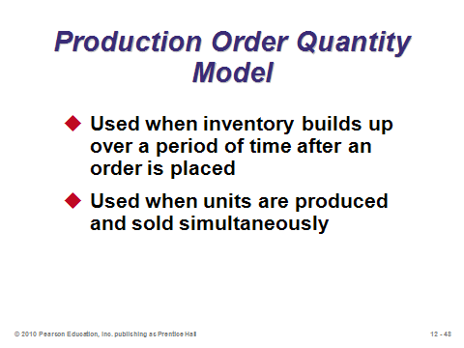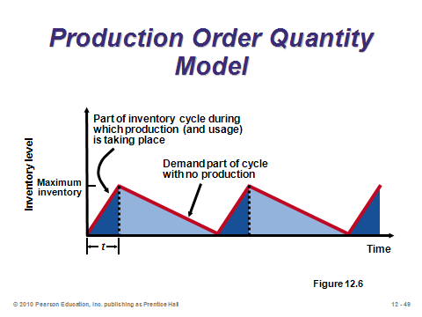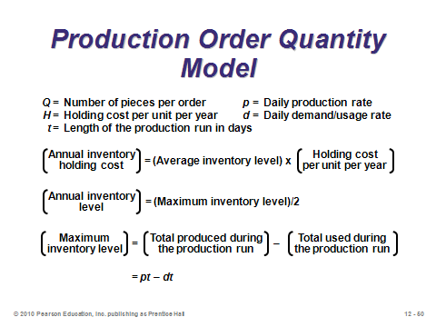

**12-48 12-49 12-50**

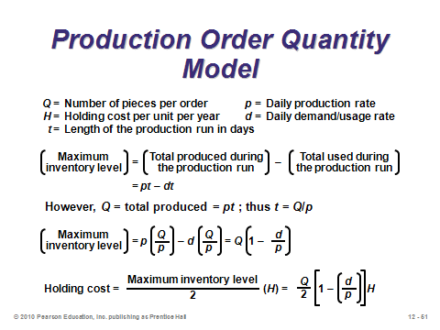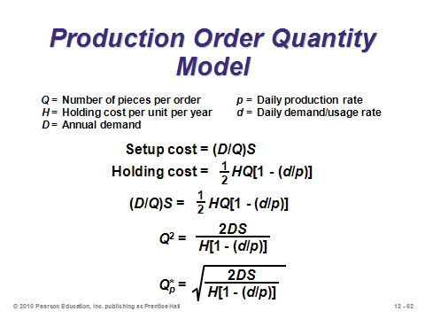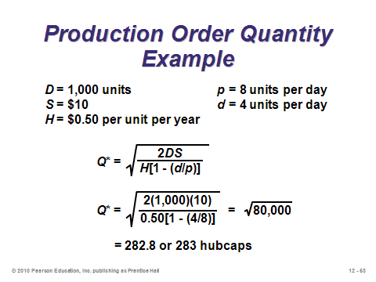

**12-51 12-52 12-53**

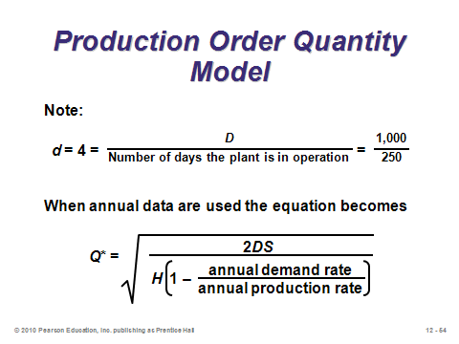

**12-54**

Quantity Discount Models (12-55 through 12-61)

Slide 55: Particularly with business-to-business transactions, quantity discounts are arguably more likely to exist than not. One study found that 95% of managers interviewed saw all-units quantity discounts for some of the items that they either purchased or sold. Whereas purchase cost can be ignored in the basic EOQ model, it must be considered when faced with a quantity discount price schedule. Importantly, note that *annual* purchase cost (not purchasing cost per order) is added to the annual holding and setup cost formula. As with going to the price club and buying much more toilet paper than necessary, the existence of quantity discounts may encourage buying a lot more and incurring a lot higher holding costs in order to take advantage of a great price break.

Slide 56: This slide (Table 12.2) illustrates a typical all-units quantity discount schedule.

Slide 57: This slide identifies the four-step solution procedure for the all-units quantity discount problem. It is assumed that *Q*\* will differ for each price discount because holding cost should be computed as an annual holding cost percentage *I* of unit cost *P* (which changes for each price interval). Note that this algorithm can be streamlined. Specifically, if EOQs are computed starting at the *lowest* price and working towards the highest price, once a *feasible* *Q*\* is found (meaning that *Q* would be in the correct interval to qualify for the price *P* used in the formula to generate that *Q*) all higher price intervals can be ignored. That is because the holding and setup costs would be higher (), and the purchasing cost would be higher.

Slide 58: This slide (Figure 12.7) illustrates why the upward adjustment may be necessary.

Slides 59-61: These slides illustrate Example 9 from the text. In this case, the quantities for two of the price intervals had to be adjusted upward. The overall lowest quantity was 1000, which generated the second-lowest possible price. The lowest price had too large of a holding cost penalty to make the purchasing savings worthwhile.

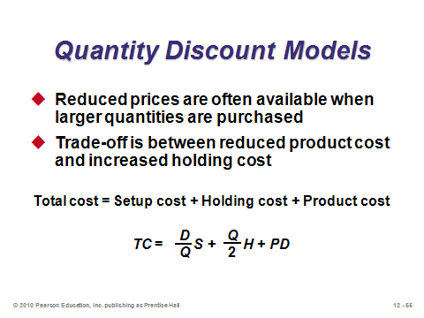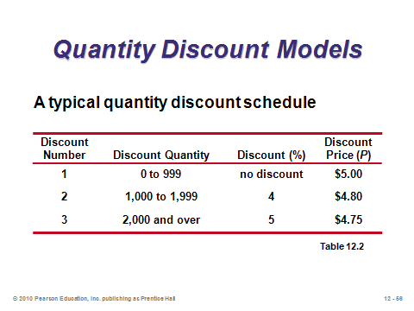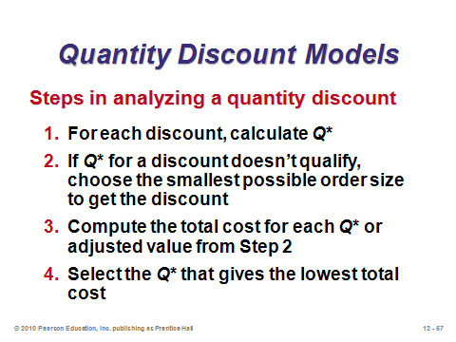

**12-55 12-56 12-57**

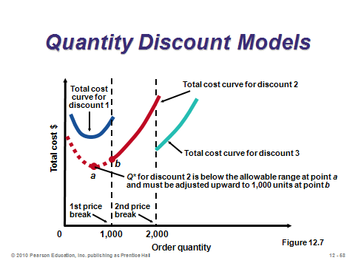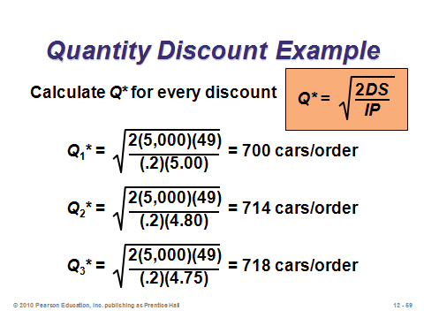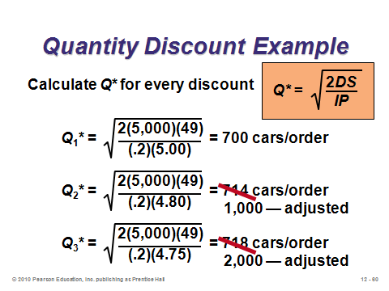

**12-58 12-59 12-60**

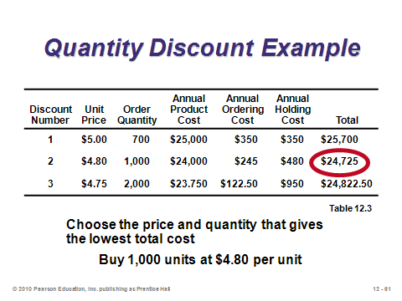

**12-61**

PROBABILISTIC MODELS AND SAFETY STOCK (12-62 through 12-75)

Slide 62: From a research perspective, stochastic inventory models can be quite complicated. Most real-world systems take a relatively straightforward approach to incorporating random demand. Clearly, in the real world most demand has a random component. Thus, most firms should be expected to keep on hand some level of safety stock in order to account for this demand uncertainty. This slide modifies the reorder point formula to incorporate this safety stock cushion, and it also provides the formula for annual stockout costs.

Slides 63-64: These slides illustrate Example 10 from the text, which illustrates the selection of optimal reorder point if given a discrete demand distribution and a known stockout cost.

Slides 65-67: Because the actual cost of a stockout may be hard to identify, managers often base safety stock level on a desired cycle service level, defined as the probability of not running out of stock during demand lead time. (Other service levels may be considered, such as *fill rate*, but calculations for those are beyond the scope of this text.) Demand during lead time in these formulas is assumed to be normally distributed. Slides 65 (Figure 12.8) shows how the reorder point is increased to account for safety stock. Slide 66 provides the new ROP formula, where safety stock is computed as *Z* (based on desired service level applied to the standard normal distribution table) times the standard deviation of demand during lead time. Slide 67 illustrates the effect of safety stock. For a given standard deviation, safety stock increases as desired service level (Z-value) increases. Note that because we assume a normal distribution, half the time demand will be *less* than average. Thus, zero safety stock will still lead to a service level of 50%.

Slide 68: This slide (Example 11) calculates safety stock and reorder point.

Slides 69-75: Several introductory texts only speak about safety stock for uncertain demand, but firms may need safety stock to cover uncertain *supply* as well. Slide 69 identifies three additional models that are provided in this text that incorporate uncertain supply and the case where standard deviation of lead time demand is not known. The following six slides provide the respective formulas and an example: Slide 70—variable demand and constant lead time, Slide 71—Example 12 illustrating Slide 70, Slide 72—variable lead time and constant demand, Slide 73—Example 13 illustrating Slide 72, Slide 74—variable demand and lead time, and Slide 75—Example 14 illustrating Slide 74. Students sometimes have difficulty grasping why standard deviation per day is multiplied by the square root of the lead time in days. In fact, demand is proportional in time, but standard deviation is not. This occurs because, according to probability theory, independent *variances* can be summed, but the standard deviation is the square root of the variance. Thus, for example, for a four-day lead time, if the standard deviation per day is 100, then the standard deviation over four days equals 

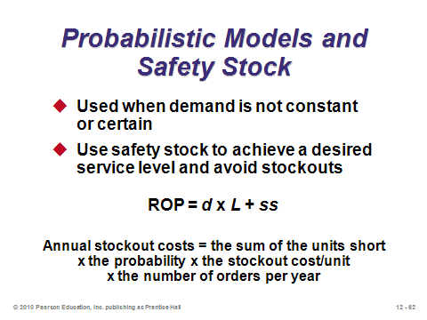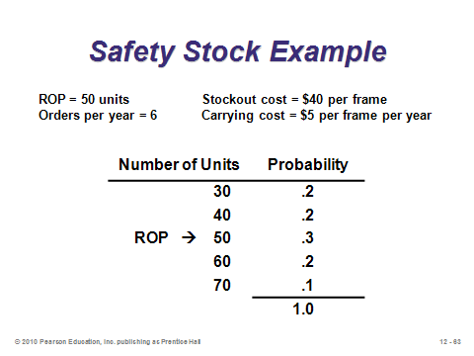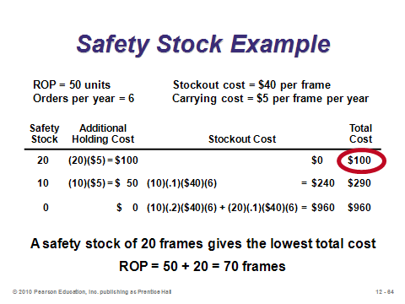

**12-62 12-63 12-64**

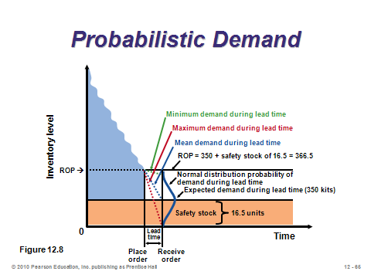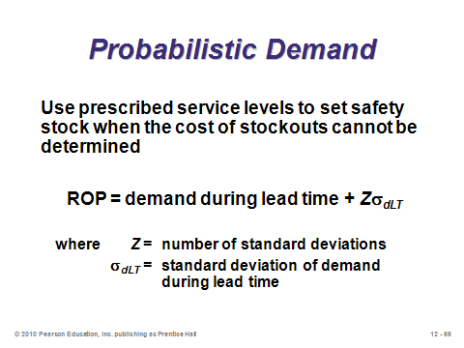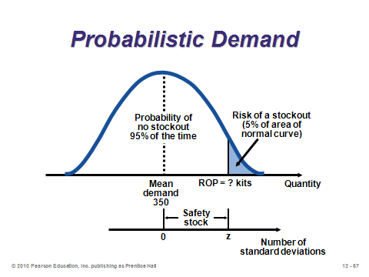

**12-65 12-66 12-67**

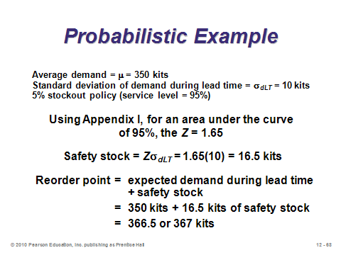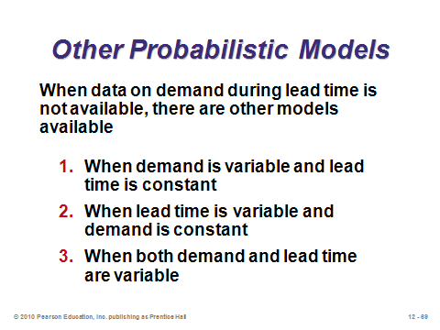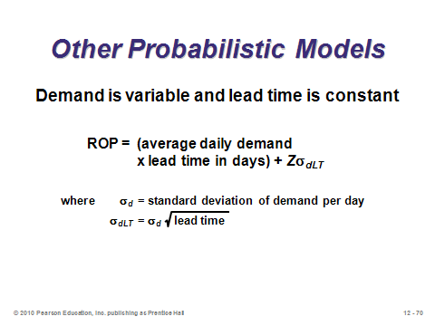

**12-68 12-69 12-70**

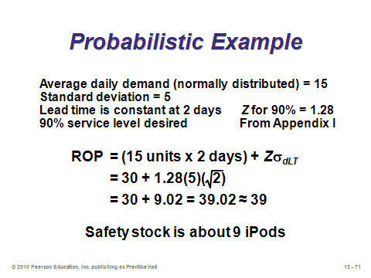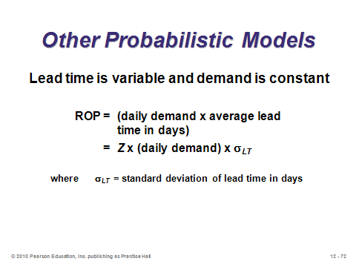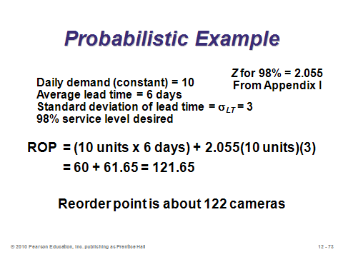

**12-71 12-72 12-73**

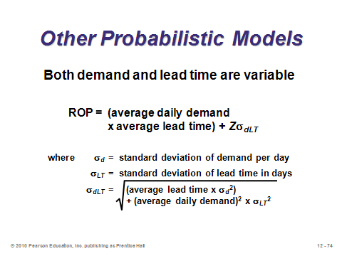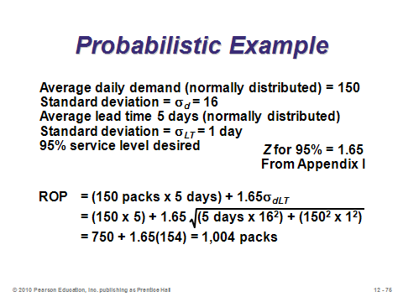

**12-74 12-75**

SINGLE-PERIOD MODEL (12-76 through 12-78)

Slide 76: Also known as the *newsstand* or *newsvendor* model, the single-period model forms the basis for much research conducted in operations management. Given a single selling season with only one chance to purchase, the interesting result is that the manager should *not* order the expected value of demand (in general). Instead, the optimal order quantity trades off the relative costs of shortage and overage. If it costs more to have too much than too little, then an amount less than the expected value should be ordered. On the other hand, if overage cost is less than shortage cost, then more than the expected value should be ordered. The stockout cost is easier to estimate in the single-period model than in multi-period models because there is not a later chance to purchase the item (no backorders) and, with only one period, goodwill loss may be minimal—thus, stockout cost simply equals lost profit. Applications in addition to those listed in the text might include July 4th fireworks stands, new release videos, and ordering pizza for a large meeting. Example 15 in the text illustrates the method for solving the problem if demand is normally distributed (find the *Z*-value corresponding to the service level from (12-18) and set *Q* = μ + *Zσ*). Note that when the overage cost exceeds the shortage cost, *Z* will be negative and the firm should order less than expected demand. Finally, the newsstand problem can be solved for any distribution, not just the normal. In each case, order *Q\** such that the distribution function at that point equals the service level, i.e., F(*Q\**) = *Cs* / (*Cs* + *Co*).

Slides 77-78: These slides illustrate Example 15 from the text. Note how the stockout risk equals 1 – service level.

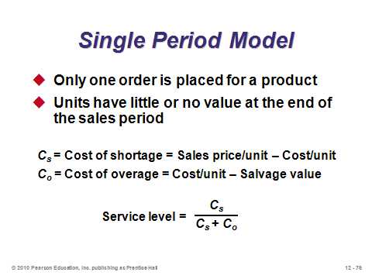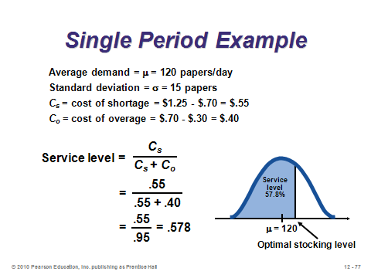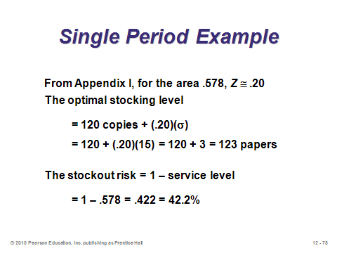

**12-76 12-77 12-78**

FIXED-PERIOD (P) SYSTEMS (12-79 through 12-82)

Slide 79: The inventory models considered up to the last section of the chapter are known as fixed-quantity (*Q*) systems, or *continuous review* systems. Another very popular system in practice is the fixed-period (*P*) system, otherwise known as *periodic review*. Instead of having a fixed order size every time and having a variable time between orders, a *P* system has a variable order size every time and a constant time between orders. For example, the purchaser might place an order every Friday afternoon (*P* = 1 week). The value of *P* can be determined by management, or it might be based on the average time between orders if the EOQ were ordered every time. When it is time to order, *Q* = *T* – *IP*, where *T* = the target quantity (average demand during (*P* + lead time) + safety stock (where σ covers (*P* + lead time)), and *IP* = on-hand inventory + scheduled receipts – backorders.

Slide 80: This slide (Figure 12.9) illustrates how a *P* system works. An effective analogy can be the process of filling water glasses in a restaurant. A server might be instructed to visit each table every five minutes (*P*). Once there, he or she fills each water glass to the top (*T*). Customers who drank a lot during the previous five minutes get a lot more water (*Q*), whereas those who drank little or no water are poured a small amount or even none.

Slide 81: This example illustrates, given a *T*, how to compute *Q* based on the inventory position *IP*. In this case, the order size exceeds the target quantity because three jackets have been backordered, and the system needs to catch up.

Slide 82: This slide presents characteristics of *P* systems. The primary advantage of a *P* system is convenience, i.e., the purchaser does not have to monitor inventory continuously and place an order at a moment’s notice. The primary disadvantage is being less able to react quickly to large orders, implying either a lower service level or a higher cost in the form of more safety stock. Fixed-period systems do make it easier to combine orders from the same supplier, which could reduce overall ordering costs, allow for combined shipments, or allow for volume discounts based on total dollar volume purchased. On the other hand, the fixed lot sizes in fixed-quantity systems may help the firm obtain discounts each time when those discounts are based on amount purchased per item, or they may help when there are specific capacity limits or desired packaging/shipping sizes.

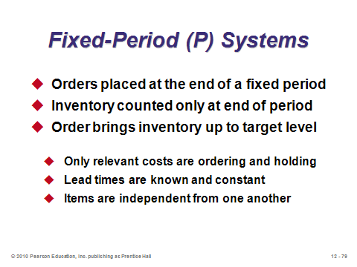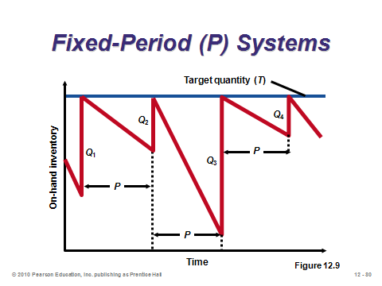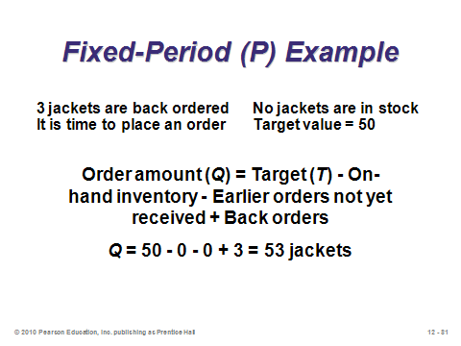

**12-79 12-80 12-81**

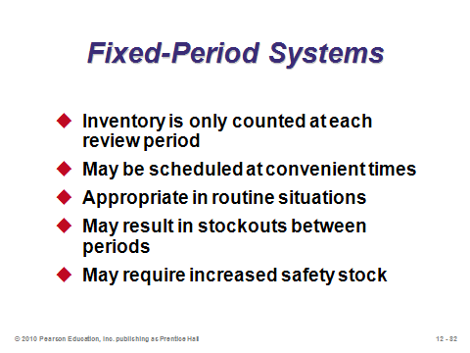

**12-82**

**Additional Assignment Ideas**

1. Visit Inventory Management at http://www.inventorymanagement.com and list the services it provides to businesses.
2. Visit APICS: The Association for Operations Management (previously known as the American Production and Inventory Control Society) at http://www.apics.org and list two upcoming educational events or programs that would be appropriate for students.

**Additional Case Studies**

Internet Case Studies (www.pearsonglobaleditions.com/heizer)

* *Southwestern University: F*: The University must decide how many football day programs to order, and from whom.
* *LaPlace Power and Light*: This utility company is evaluating its current inventory policies.

Harvard Case Studies (http://harvardbusinessonline.hbsp.harvard.edu)

* *Pioneer Hi-Bred International, Inc.* (#898-238): Deals with the challenges in managing inventory in a large, complex agribusiness firm.
* *L. L. Bean, Inc*.: Item Forecasting and Inventory (#893-003): The firm must balance costs of understocking and overstocking when demand for catalog items is uncertain.
* *Blanchard Importing and Distribution Co., Inc*. (#673-033): Illustrates two main types of errors resulting from the use of EOQ models.

Richard Ivey School of Business (http://cases.ivey.uwo.ca/cases/pages/home.aspx)

* *Progistix-Solutions Inc. – The Critical Parts* (#9B05D002): Class discussion can include issues related to supply chain partnerships, outsourcing, inventory management and demand forecasting. Data provided in the case allow students to develop implementation plans and set specific performance targets.
* *Elite Rent-a-Car* (#9B07E011): The president and founder of a premier luxury car rental agency located throughout Europe must decide on the composition of the fleet of cars for the upcoming summer season. She has to balance a desire for high utilization versus the possibility of having to turn away clients if they request a car that is not in stock.

**Internet Resources**

|  |  |
| --- | --- |
| APICS: The Association for Operations Management | www.apics.org |
| Institute of Industrial Engineers | www.iienet.org |
| Inventory Control Forum | www.cris.com/~kthill/sites.htm |
| Inventory Management | www.inventorymanagement.com |

**Other Supplementary Material**

Videos/Films

Film available from:

Humanities and Sciences

(P) 800-257-5126

(F) 609-275-1400

(E) custserv@films.com

http://www.films.com

* *The Story of Inventory* (Item# BVL29654)

Models

A myriad of additional inventory models can be presented along with Chapter 12 for those who are interested, including the intentional allowing of backorders, warehouse space or budget constraints, and joint replenishment models. One interesting and relatively easy one would help with business-to-business transactions. Specifically, the EOQ model assumes typical consumer demand, which may be uniform and continuous. However, what about a supplier who’s major customer orders its EOQ? This creates a *lumpy* demand pattern, rather than a uniform pattern. The inventory graph goes down in a stair-step pattern, rather than as a straight line.

It turns out that the optimal order quantity for the supplier in such a lumpy demand environment is to order an integer multiple *n* of the size of its incoming orders *Q*. So the supplier’s decision variable is an integer, and the formula is: , where *D* is the same annual demand faced by the EOQ-ordering customer. The supplier’s order size is *n*\**Q*. The supplier’s annual setup and holding costs equal:  Instructors who want to take this one step further can present a nice illustration of supply chain management by comparing the system costs of jointly determined lot sizes with individually determined lot sizes. Details can be found in Munson, C.L., J. Hu, and Rosenblatt, M.J. (2003), “Teaching the Costs of Uncoordinated Supply Chains,” *Interfaces*, 33(3), 24-39.

Learning Game

**Teaching Note**

**Decision-Making Exercise**

**Inventory Simulation Game**

***"He Shoots, He Scores"***

**Purpose**:

This decision-making exercise allows students to observe the inherent complexities in making inventory replenishment decisions in a stochastic demand environment. It is purposely designed as a fairly simple game that can be played in one class period (30-45 minutes). There are three components, this teaching note, a spreadsheet, and the student instructions.

**Spreadsheet: (The spreadsheet is located on the Instructor’s CD)**

The spreadsheet calculates cumulative profits throughout the game for each team.

At times it may be desirable to use different demand figures in various sections (especially if the sections follow one another). As such, the spreadsheet supplied includes 3 different sets of actual demand figures (along with the optimal solution for each). The instructions remain the same regardless of which is used.

**Procedure: (The Student Instructions follow this Teaching Note and are located on the Instructor’s CD)**

Form groups of 3 – 6 students such that there are about 10 groups in total.

The students begin the game with no units on-hand. After they decide how much to order in July and it has been recorded on the spreadsheet, announce the demand for that month and input it into the spreadsheet (demands given on the next page). After they have completed their inventory calculations and made their replenishment decision for the next month, announce the next month’s demand, and so on. The spreadsheet should be projected at the front of class so students get a "month-by-month" picture of simulation results. Most students enjoy the game more if they only fill in the top 5 rows of the worksheet, keeping track of their inventory position. Some groups also fill in the bottom of the worksheet, but this is not necessary to get the learning value from the game.

It is vital that student teams correctly grasp the calculation of the amount sold (minimum of: demand or stock on hand) and inventory position (minimum of: stock on hand – demand or zero (if all units were sold). Teams ought to use the accompanying inventory table to record their respective ending inventories, their inventory position, and to keep track of their monthly replenishments. It is usually a good idea to check with each group after the 2nd or 3rd month to ensure they are calculating this correctly. This can be done by showing the students the blue portion of the spreadsheet with this information so they can compare their by-hand calculations.

The winning group will be, obviously, the one that has the highest annual profit. After the game has been completed, it may be desirable to show the optimal solution produced with the Wagner-Whitin dynamic programming method (included with the spreadsheet, but “hidden” to avoid showing it prematurely). The students can be told that this method assumes that you knew the monthly demands in advance. As a result, the annual profit realized from this method is an "upper bound" on the profit they could have obtained without knowing demands in advance. The problem of determining optimal replenishment decisions when facing stochastic demand is an exceedingly difficult problem (heuristic procedures are often used to obtain "good" solutions in these cases).

|  |  |  |  |
| --- | --- | --- | --- |
| **Demands for the 3 games** | | | |
|  |  |  |  |
|  | **A** | **B** | **C** |
| July | 29 | 26 | 30 |
| August | 40 | 56 | 49 |
| September | 55 | 33 | 45 |
| October | 99 | 84 | 73 |
| November | 32 | 49 | 39 |
| December | 79 | 79 | 82 |
| January | 93 | 43 | 63 |
| February | 40 | 55 | 68 |
| March | 36 | 35 | 27 |
| April | 17 | 22 | 20 |
| May | 28 | 27 | 26 |
| June | 18 | 23 | 22 |
|  |  |  |  |
| **Total Demand** | **566** | **532** | **544** |

Designed by: Keith Willoughby, Bucknell University

Ken Klassen, Brock University

*Note: This game has been developed for educational purposes. It may be used, disseminated, and modified for educational purposes, but it may not be sold. In all uses of the game, the original developers must be acknowledged (as has been done above).*

© Keith Willoughby and Ken Klassen, 2003

**Decision-Making Exercise:**

**Inventory Simulation**

***"He Shoots, He Scores"***

**Student Instructions**

At a recent trade show, a Canadian company unveiled its radical new product for the sports equipment industry - a graphite hockey stick! The company, known as *"He Shoots, He Scores"* has enthusiastic plans for the stick. As owner of a medium-sized retail sporting goods store, you are aware of the various costs involved in ordering and holding inventory. Taking into account the respective costs, you are to develop an appropriate ordering policy for this brand-new item.

Since this is a new product, you have no historical data on which to base your forecast of demand. However, you have data on the number of sticks sold for other new, state-of-the-art sticks from prior years:

|  |  |  |  |  |  |  |
| --- | --- | --- | --- | --- | --- | --- |
|  | **2 years ago** | **Last year** |  |  | **2 years ago** | **Last year** |
| **Jul** | 20 | 24 |  | **Jan** | 34 | 68 |
| **Aug** | 35 | 44 |  | **Feb** | 41 | 62 |
| **Sep** | 59 | 49 |  | **Mar** | 38 | 33 |
| **Oct** | 79 | 100 |  | **Apr** | 19 | 26 |
| **Nov** | 42 | 51 |  | **May** | 27 | 26 |
| **Dec** | 83 | 81 |  | **Jun** | 25 | 21 |

As in any business, sales for any given month could be extremely volatile (or not). In this game, the demand for the next year is generated from a Normal distribution (which ranges from negative infinity to infinity). It is not necessary to know the parameters of the Normal distribution for this game, but they are given at the end of these instructions.

*"He Shoots, He Scores"* will allow you to purchase hockey sticks for $20. Market research results given at the recent trade show indicated that potential customers would pay up to $30 for the item. Thus, you plan to use $30 as your selling price. Note that the amount you sell in a given month is always the lowest of either monthly demand or (beginning inventory + quantity ordered).

Placing an order costs you $60 (note that the manufacturer allows at most one replenishment per month). Any unsatisfied demand (a stockout, or should we call it a "stick" out?) costs you $7 per unit short. Backorders are not allowed (since customers will most likely purchase the hockey stick from a competitor if you don't have enough on-hand). Inventory remaining at the end of a month costs you $1 per unit.

Your task is to plan replenishments (when to order, how much to order) on a month-by-month basis for the next 12 months. Assume that the first month in the planning horizon is July, and that there is no inventory on-hand. After you make your replenishment decision, the instructor will announce the demand for that month. Then, you may make the decision for next month. Use the attached table to indicate your monthly replenishments, and to tabulate the results of your respective strategy. If a stockout occurs, write "0" for the ending inventory, and put a "0" for the beginning inventory of the subsequent month.

**For example,** assume that there were no units in beginning inventory, and that you ordered 15 sticks at the beginning of July. Assuming a demand of 23 sticks, you would face the following costs:

* revenue: $30 * min(0+15,23) = $30 * 15 = $450
* ordering cost: $60 + ($20 * 15) = $360
* shortage cost: $7 * 8 = $56
* holding cost: 0 (since there is no ending inventory - i.e. we had a stockout)
* monthly profit = $450 - ($360 + $56) = $34

**Parameters for Normal Distribution:**

Normal( (D2+D1*3) / 4 , Absvalue(D1-D2) )

where: D1 is demand last year

D2 is demand 2 years ago

Thus, demand for July is calculated from: Normal ((20+24*3) / 4, Absvalue(24-20))

Normal (23,4)

Designed by: Keith Willoughby, Bucknell University

Ken Klassen, Brock University

*Note: This game has been developed for educational purposes. It may be used, disseminated, and modified for educational purposes, but it may not be sold. In all uses of the game, the original developers must be acknowledged (as has been done above).*

© Keith Willoughby and Ken Klassen, 2003

|  |  |  |  |  |  |  |  |  |  |  |  |  |  |
| --- | --- | --- | --- | --- | --- | --- | --- | --- | --- | --- | --- | --- | --- |
| **Worksheet** | | | | | | | | | | | | | |
|  |  | July | Aug. | Sept. | Oct. | Nov. | Dec. | Jan. | Feb. | March | April | May | June |
| 1 | Beg. Inventory | **0** |  |  |  |  |  |  |  |  |  |  |  |
| 2 | Order quantity |  |  |  |  |  |  |  |  |  |  |  |  |
| 3 | Number available  = (1) + (2) |  |  |  |  |  |  |  |  |  |  |  |  |
| 4 | Demand |  |  |  |  |  |  |  |  |  |  |  |  |
| 5 | End. Inventory  = max[(3)-(4), 0] |  |  |  |  |  |  |  |  |  |  |  |  |
|  | **Revenue**: |  |  |  |  |  |  |  |  |  |  |  |  |
| 6 | Sales  = $30 * min [(3), (4)] |  |  |  |  |  |  |  |  |  |  |  |  |
|  | **Costs**: |  |  |  |  |  |  |  |  |  |  |  |  |
| 7 | Ordering  If (2)>0, = $60 + ($20* (2)), If (2)=0, = 0 |  |  |  |  |  |  |  |  |  |  |  |  |
| 8 | Shortage  = - $7 * min[0, (3)-(4)] |  |  |  |  |  |  |  |  |  |  |  |  |
| 9 | Holding  = $1 * (5) |  |  |  |  |  |  |  |  |  |  |  |  |
| 10 | **Total Costs**  = (7) + (8) + (9) |  |  |  |  |  |  |  |  |  |  |  |  |
| 11 | **Monthly Profit**  = (6) - (10) |  |  |  |  |  |  |  |  |  |  |  |  |
| 12 | **Annual Profit** |  |  | | | | | | | | | | |